STEVE technical documentation

By Joshua Foulkes

# MBED board pinout

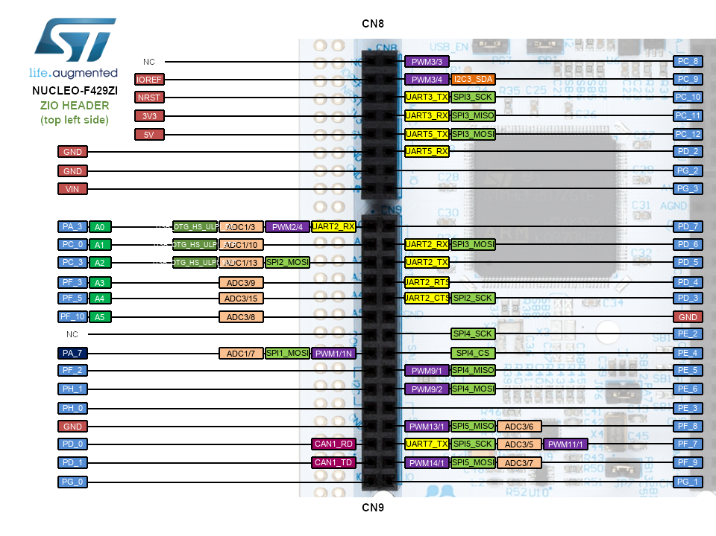

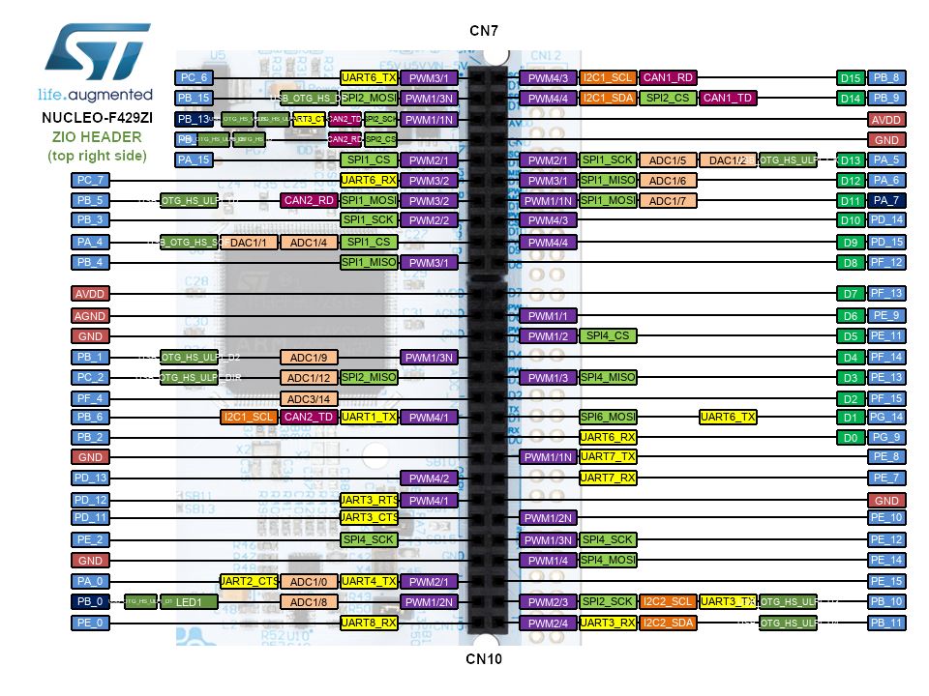

# Coordinate frames



# Leg rotation

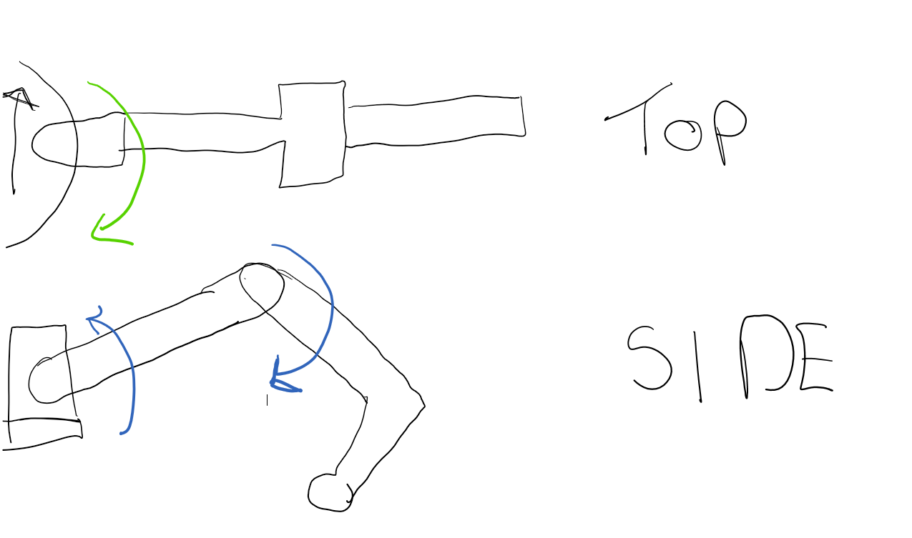

# Board pinout colours

## Adafruit PCA9865

|  |  |  |
| --- | --- | --- |
|  | Colour | Pin name |
|  | Brown/grey | Ground |
|  | Red | SCL |
|  | Orange | SDA |
|  | Yellow | Vcc |

## Adafruit INA260

|  |  |  |
| --- | --- | --- |
|  | Colour | Pin name |
|  | Grey | Vcc |
|  | Purple | Ground |
|  | Blue | SCL |
|  | Green | SDA |

# Camera

Address for high quality: “raspberry pi ip”:8081

Address for low quality: “raspberry pi ip”:8082

# To add

Diagram of button circuit orange1 yellow2 green3 blue4

Pin uses